INT 374
PROJECT REPORT
(Project Semester October-December 2025)

Sales Performance Analysis and Dashboard Reporting Using Power Bi

Submitted by
Deepak Chaudhary
Registration No: 12302841
B.Tech CSE - K23KT
Course Code: INT 374

Under the Guidance of
Kr. KARAN BAJAJ
DISCIPLINE of CSE/IT
School of Computer Science and Engineering
Lovely Professional University, Phagwara

CERTIFICATE
This is to certify that Deepak Chaudhary bearing Registration no. 12302841 has completed INT 374 project titled, “Sales Performance Analysis and Dashboard Reporting Using Power Bi” under my guidance and supervision. To the best of my knowledge, the present work is the result of his/her original development, effort and study.
Signature and Name of the Supervisor
Dr. KARAN BAJAJ
School of Computer Science and Engineering
Lovely Professional University
Phagwara, Punjab.
Date: 16-12-25

DECLARATION
I Deepak Chaudhary, student of B. Tech CSE - K23KT under CSE Discipline at, Lovely Professional University, Punjab, hereby declare that all the information furnished in this project report is based on my own intensive work and is genuine.
Date: 16-12-25 Signature
Registration No. 12302841
Name-Deepak Chaudhary

ACKNOWLEDGEMENT
I would like to express my sincere gratitude to my faculty guide Dr.KARAN BAJAJ for his valuable guidance, support, and encouragement throughout this project. I am thankful to Lovely Professional University for providing the necessary resources and environment for conducting this project successfully. I also extend my appreciation to all those who directly or indirectly contributed to the completion of this report.

TABLE OF CONTENTS

1. Introduction
2. Source of dataset
3. EDA process
4. Analysis on dataset (for each analysis)
i. Introduction
ii. General Description
iii. Specific Requirements, functions and formulas
iv. Analysis results
v. Visualization
5. Conclusion
6. Future scope

1. Introduction
This project analyzes retail sales data using Microsoft Power BI to understand overall business performance and customer trends. The main objective is to perform exploratory data analysis (EDA) and present key insights through interactive dashboards. The analysis helps compare sales across cities, shop types, shop sizes, and product categories to support better business decision-making.

2. Source of Dataset
The dataset used for this analysis was provided through the INT 374 coursework and contains detailed transaction-level sales data. This includes information such as product categories, shop details, sales values, ratings, and shop opening years and other attributes useful for analytical purposes. The dataset represents a real-world retail scenario and is suitable for business intelligence analysis using Power BI.

3. EDA Process
Exploratory Data Analysis (EDA) is the initial step in data analysis that focuses on summarizing the main characteristics of a dataset. The following EDA techniques were used:
- Handling missing or inconsistent data entries
- Cleaning column names and formatting
- Deriving time-based fields like month/year from order date
- Aggregating sales and profit by region, category, and time
- Visualizing key performance indicators using Power Bi
- Identifying trends, outliers, and relationships in the dataset

4. Analysis on Dataset
The dataset used in this project represents retail transaction records, capturing detailed sales, customer, and shipment information. Here's a breakdown of the analysis performed:

1. Total Sales by City Type
This chart shows the total sales contribution of different city tiers.
Tier 3 cities generate the highest sales (472K), followed by Tier 2 cities (393K), while Tier 1 cities contribute the lowest sales (336K).
This indicates that non-metro and semi-urban areas play a major role in overall sales, possibly due to a higher number of shops or increased dependence on quick-commerce services in these regions.

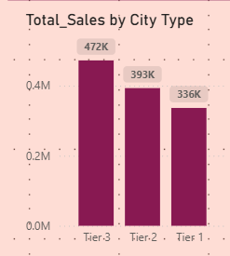

2. Total Orders by City Type
This chart shows the distribution of total orders across city tiers.
Tier 3 cities account for the highest number of orders, followed by Tier 2, while Tier 1 cities place comparatively fewer orders.
This suggests that customers in Tier 3 cities rely more on online grocery services, leading to a higher order volume.

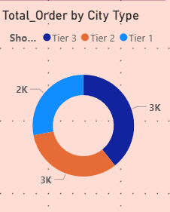

3. Shop Type Performance
This table compares sales and order performance across different shop types.
Supermarket Type 1 records the highest total sales and total orders, making it the strongest contributor to overall revenue.
Average sales remain almost similar across all shop types, indicating consistent order value.
Customer ratings are also stable (around 3.9) across shop types, suggesting comparable customer satisfaction.

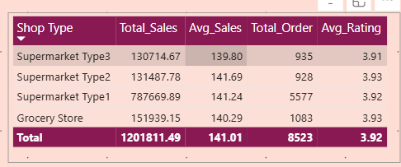

4. Sales and Orders by Shop Size
This chart shows how shop size impacts sales and order performance.
Medium-sized shops contribute the highest total sales and orders, followed by small shops, while large shops contribute the least.
This suggests that medium-sized shops are the most efficient, balancing product variety and operational capacity better than very small or very large stores.
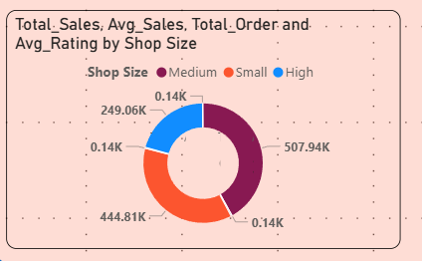

5. Shops Opening Year wise
This chart shows the number of shops opened each year.
Shop openings were highest in 2021 and remained almost stable until 2023, but there is a sharp decline in 2024.
This indicates a slowdown in expansion, suggesting that the business may be shifting its focus from opening new shops to optimizing existing ones.
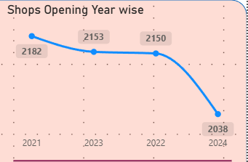

6. Total Sales by Category
This chart shows the sales contribution of different product categories.
Fruits and Vegetables and Snack Foods generate the highest sales, followed by Household and Frozen Foods.
Categories such as Meat and Soft Drinks contribute the lowest sales.
This indicates that daily essential items dominate customer purchases, while non-essential categories have comparatively lower demand.
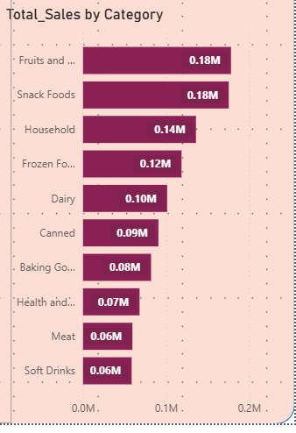

7. Key Performance Indicators
These KPIs provide a quick summary of overall business performance.
The total sales are 1.20M, generated from approximately 9K orders, with an average sales value of about 141 per order.
The average customer rating is 3.92, indicating generally positive customer satisfaction.
Together, these metrics give a high-level view of revenue, order volume, and customer experience.

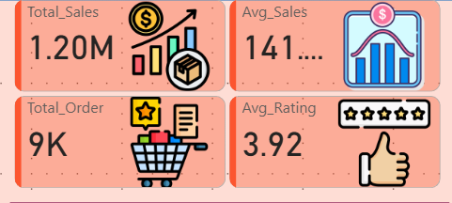

5. Conclusion
This project used Microsoft Power BI to analyze retail sales data and present key business insights through an interactive dashboard. The analysis showed that Tier 3 cities and medium-sized shops contribute the highest sales and order volumes, while essential categories such as Fruits & Vegetables and Snack Foods dominate overall sales.
Overall performance remains strong, with stable average sales and customer ratings, indicating consistent customer satisfaction. The findings suggest that future growth should focus on optimizing existing shops, strengthening high-demand categories, and improving efficiency rather than rapid expansion.
# MY DASHBOARD
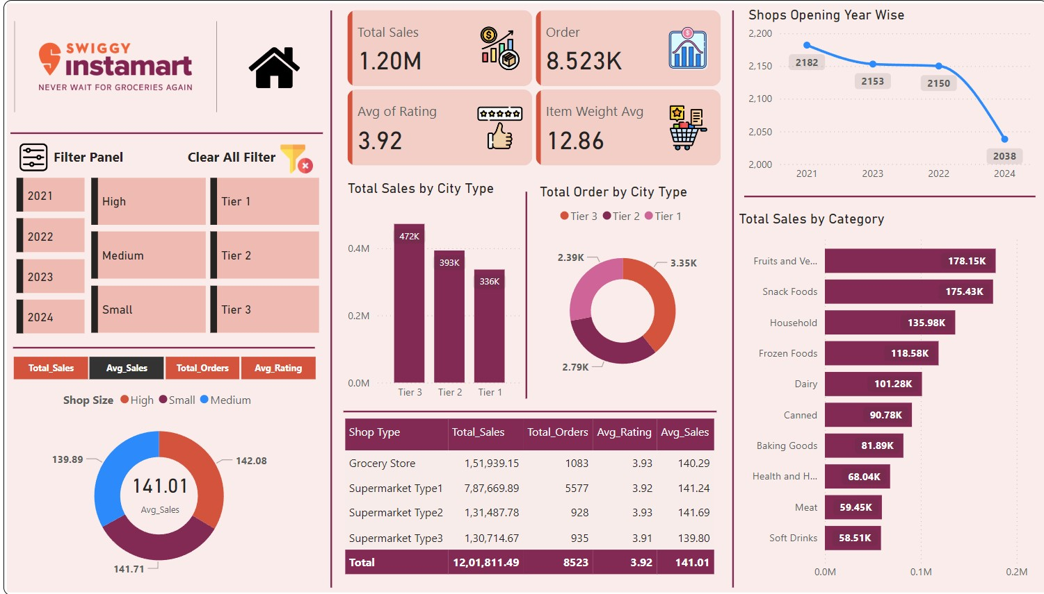

MY GITHUB PROFILE - https://github.com/DeepakCdry/Excel-Data-Visualization

DATA SET LINK –
https://catalog.data.gov/dataset/

6. Future Scope
This analysis can be extended by including profit, cost, and discount data to measure actual profitability instead of only sales. Customer-level data can be added to study repeat purchases and customer behavior.
Future dashboards may also include sales forecasting, seasonal trend analysis, and real-time data integration to support better planning and decision-making.
THANK YOU

